- Title： Implementation of Ping Utility
No. 4

Name: Khan Md Shahedul Islam
Stu No.: 2018380130
Class No.: 10101801
Time: 2020/11/15

School of computer science and Engineering, NWPU

Content

1 Purpose of the experiment 1
2 Steps for the experiment 1
3 Problems happened to the experiment 1
4 Results and analysis 3

Purpose:
On the basis of analyzing the implementation code of Ping command, make students understand the principle of implementing Ping.
By constructing ICMP echo request message, and receiving and parsing it on the target host, make students deeply understand the working principle of ICMP Protocol.

Steps Performed & Result
The ping command sends packets of data to a specific IP address on a network, and then lets me know how long it took to transmit that data and get a response. It’s a handy tool that I can use to quickly test various points of my network
How Does Ping Work?
Ping comes from a term used in sonar technology that sends out pulses of sound, and then listens for the echo to return. On a computer network, a ping tool is built into most operating systems that works in much the same way. You issue the ping command along with a specific URL or IP address. My computer sends several packets of information out to that device, and then waits for a response. When it gets the response, the ping tool shows me how long each packet took to make the round trip—or tells me there was no reply.

It sounds simple, and it is. But I can use it to good effect. I can test whether my computer can reach another device—like my router—on my local network, or whether it can reach a device on the Internet. This can help my determine if a network problem is somewhere on my local network, or somewhere beyond. The time it takes packets to return can help me identify a slow connection, or if I am experiencing packet loss.

And it pretty much doesn’t matter what operating system you’re using. Pull up a terminal or Command Prompt window, and you can use ping on macOS, Linux, or any version of Windows.
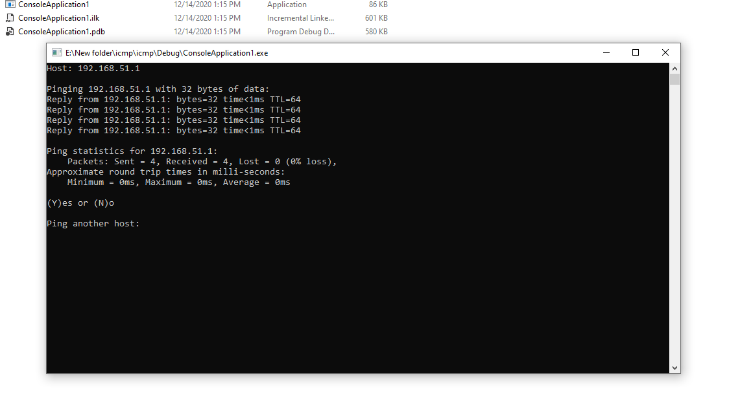
Here I have sent and received data packets by pinging my own IP address.
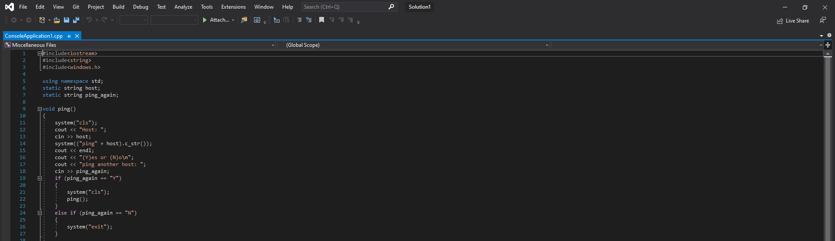

Problems Faced and Solve
- Ping a URL (like www.facebook.com) or IP address to see if I can reach an internet destination. If I get a successful response, I know that all the networking devices between I and that destination are working, including the network adapter in my computer, my router, and whatever devices exist on the internet between my router and the destination. And if I am interested in exploring those routes further, I can use another networking tool named tracert to do just that.
- Ping a URL to resolve its IP address. If I want know the IP address for a particular URL, I can ping the URL. The ping tool shows me right at the top the IP address it’s working with.
- Ping my router to see if I can reach it. If I can’t successfully ping an internet location, I can then try pinging my router. A successful response lets me know that my local network is working okay, and that the problem reaching the internet location is somewhere out of my control.
- Ping my loopback address (127.0.0.1). If I can’t successfully ping my router, but my router appears to be turned on and working, I can try pinging what’s known as a loopback address. That address is always 127.0.0.1, and pinging it successfully lets me know that the network adapter on my computer (and the networking software in your OS) is working properly.
Analysis:
I may not get a ping response from other computers on my local network because the built-in firewalls on those devices prevent them from responding to ping requests. If I want to be able to ping those devices, you’ll need to turn off that setting to allow pings through the firewall.
The list above uses a kind of outside-in approach, where I ping the furthest destination first, and then work my way in to the more local devices. Some people like to work inside-out by pinging the loopback address first, then their router (or another local device), and then an internet address.
And of course, what we’re talking about in this article is mostly about using ping to perform troubleshooting on a home or small business network. On larger networks, there’s a lot more complexity to worry about. Plus, if I am tasked with troubleshooting larger networks, I probably already know how to use ping and many other networking tools.

Design and implementation of FTP client

Purpose:
Through the design and implementation of an FTP client, deeply understand the working principle of FTP protocol, focus on the establishment process and the characteristics of communication mode of control connection and data connection in the FTP protocol implementation, and learn the multi-process communication programming method.

Steps executed and result:
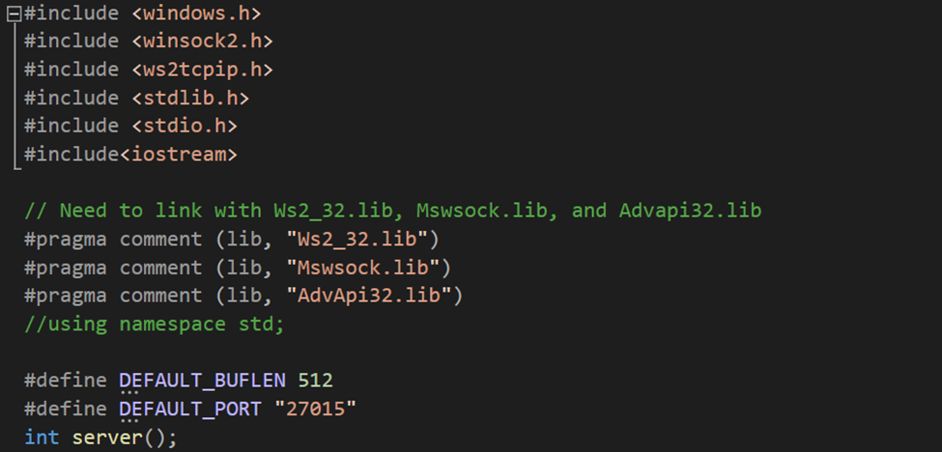
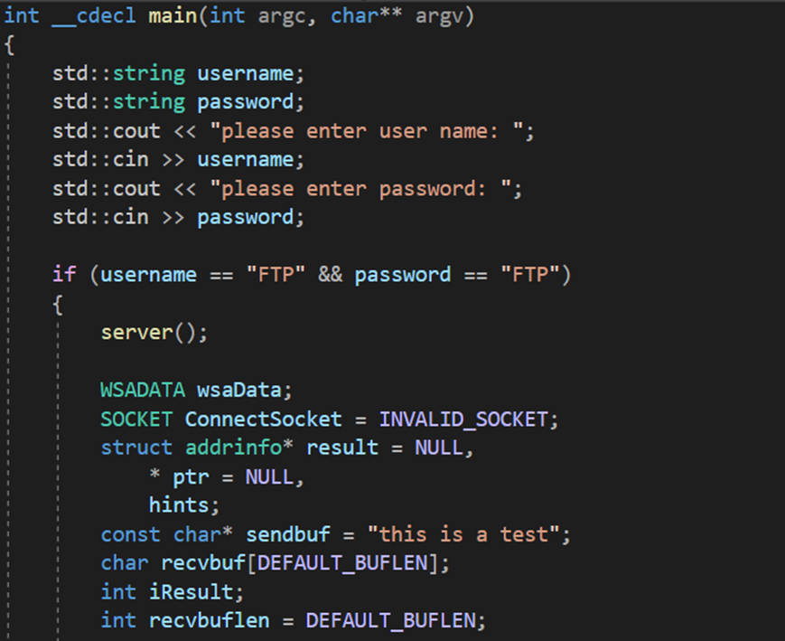
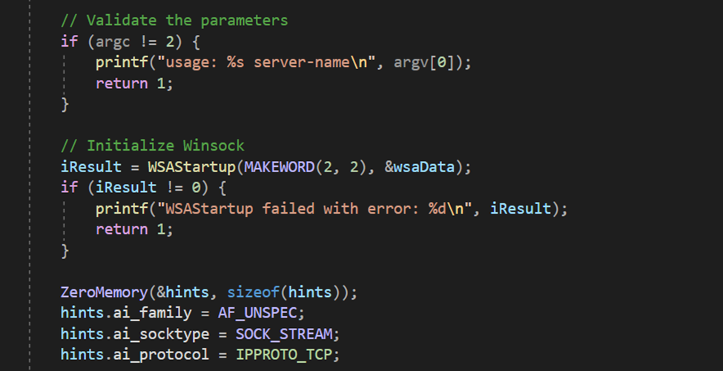
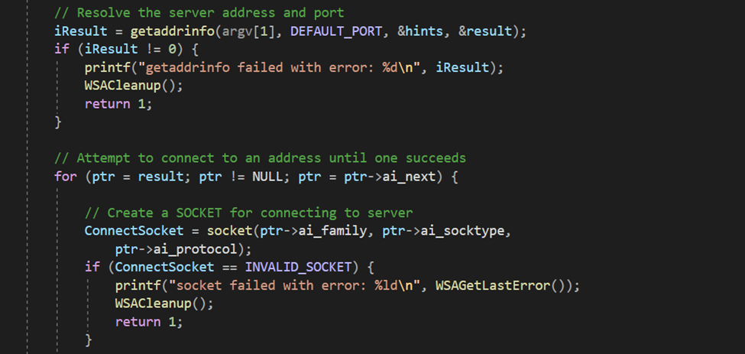
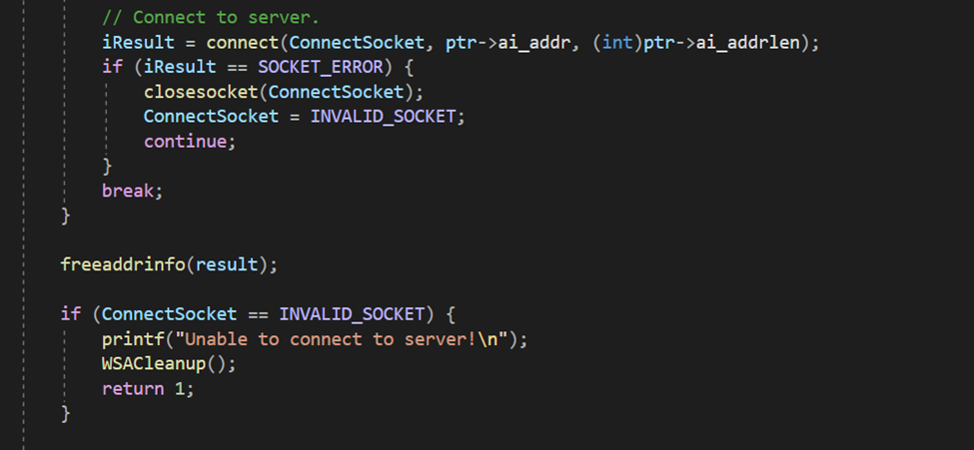

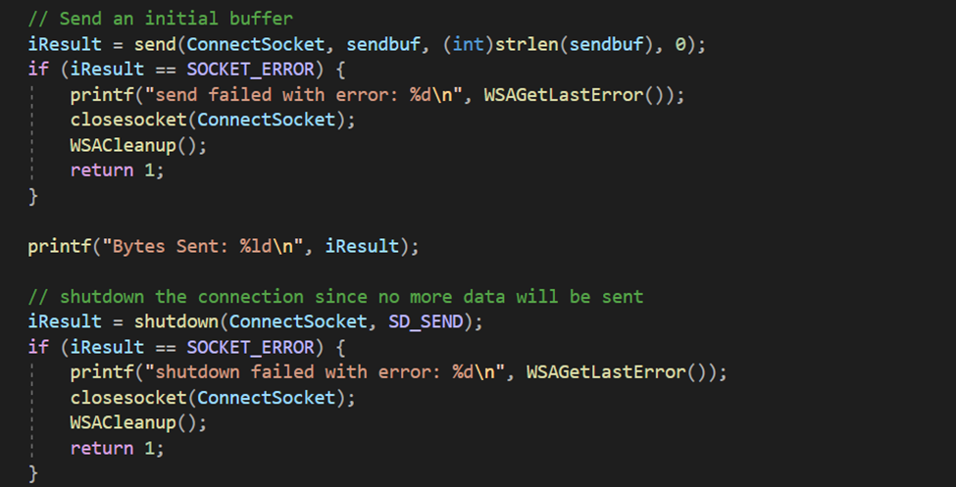
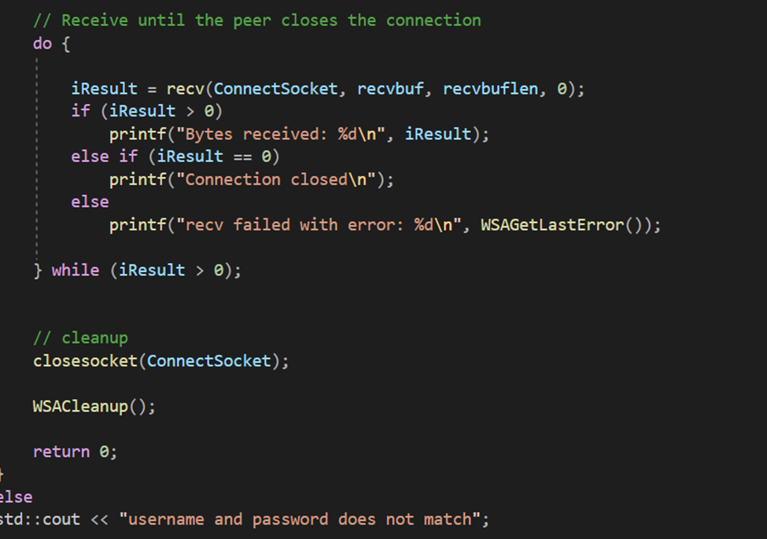
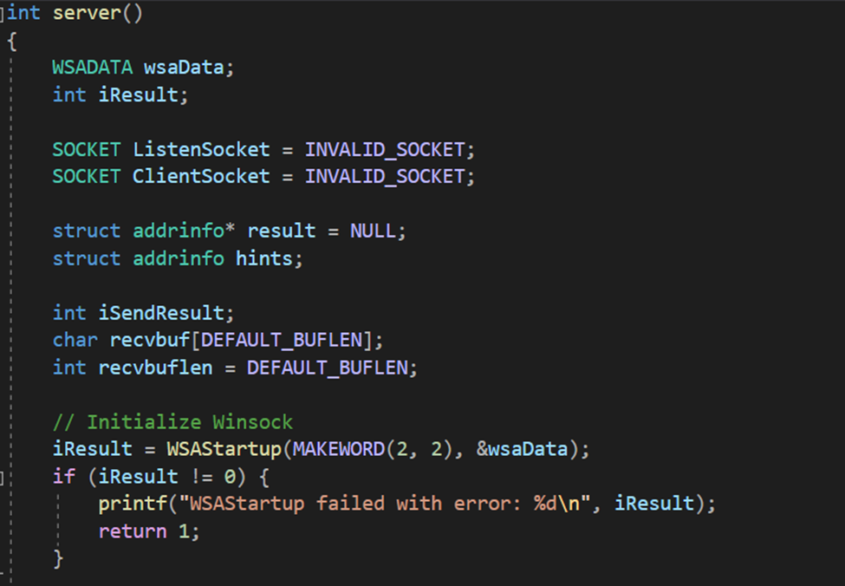
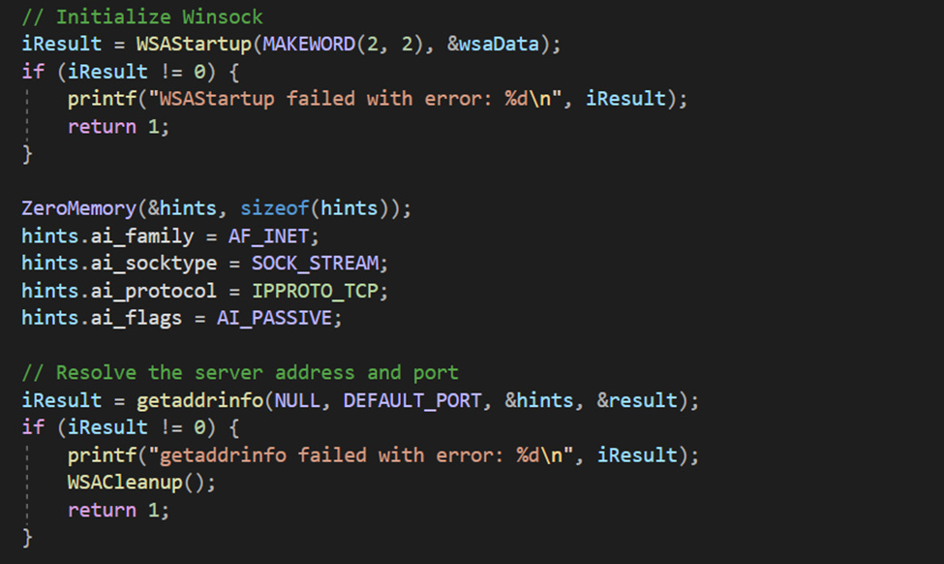
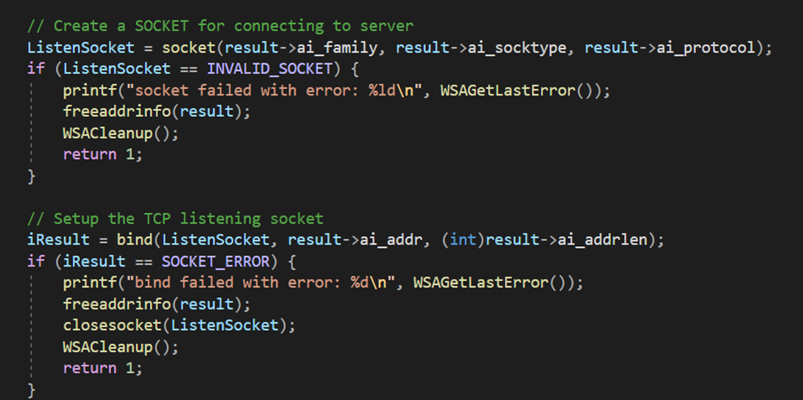
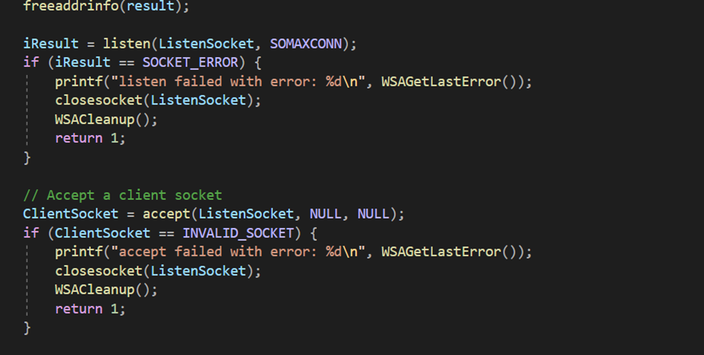
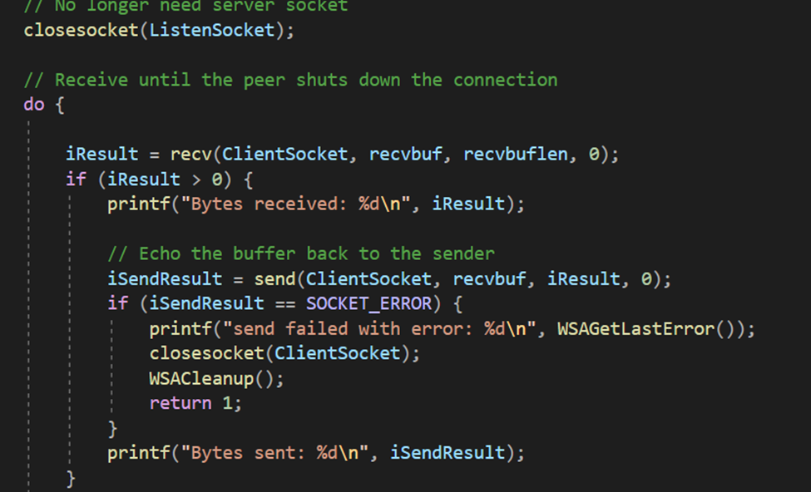
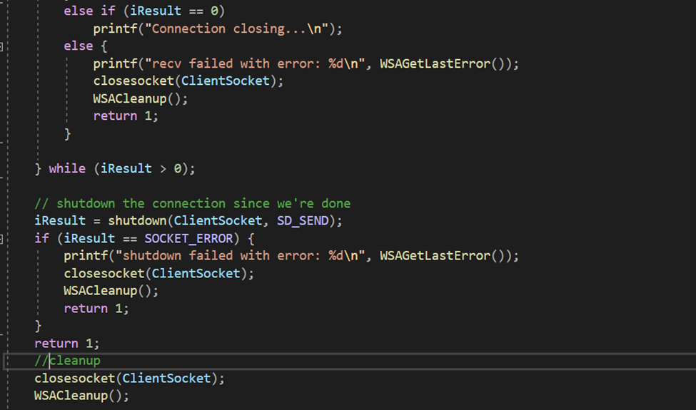
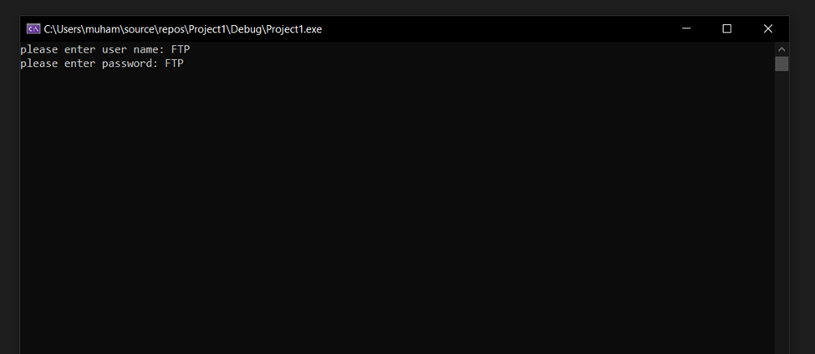
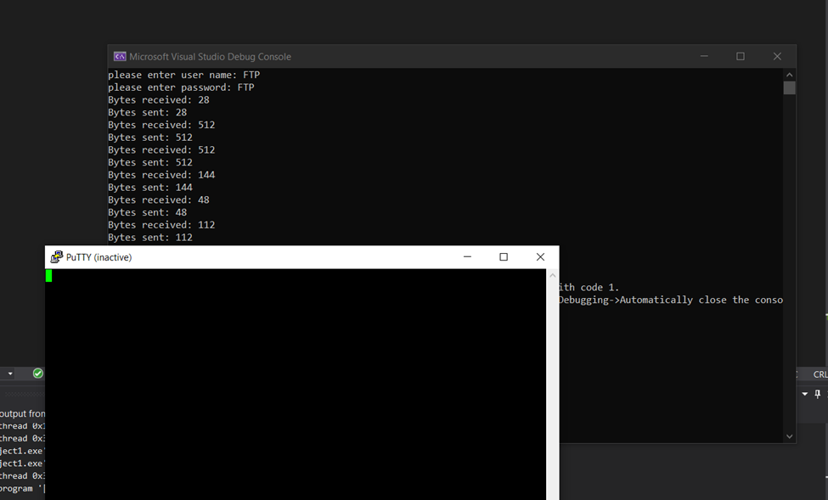
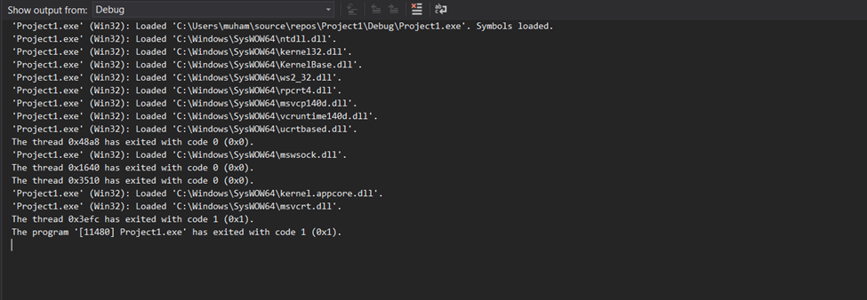
Analyze:
Active and passive modes can be a difficult idea to understand. In some ways it seems counterintuitive. The simplest explanation is that active and passive are the two modes that FTP can run in.
An FTP server can be placed in two different default modes by an administrator: Active or Passive. Active mode was originally the only method of FTP, and is therefore often the default mode for FTP. When a client and server intend to transfer data, they usually start a Control Connection first in order to negotiate the details of the Data Connection prior to opening it and transferring data. In an active mode connection, when the client makes the initial connection and sends PORT, the server initiates the second connection back.
In a passive connection, the client connects and sends the PASV command, which functions as a request for a port number to connect to. Once the client receives a port, it starts the second connection and sends data. This works in tandem with a firewall configured to employ port forwarding for added security. Data will get forwarded from the firewall’s port to the server’s port to keep outside clients from accessing the server directly.
The IP address used for the original Control Connection must be combined with an unused port—usually a port numbered higher than 1024 and lower than 65535. Ports below 1024, other than port 20, are reserved for other system services.
During the address/port negotiation phase, the client should issue either the PORT command (when initiating Active Mode) or the PASV command (when initiating Passive Mode).
Active Mode—The client issues a PORT command to the server signaling that it will “actively” provide an IP and port number to open the Data Connection back to the client.

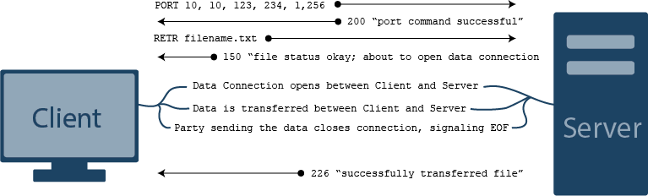

Passive Mode—The client issues a PASV command to indicate that it will wait “passively” for the server to supply an IP and port number, after which the client will create a Data Connection to the server.

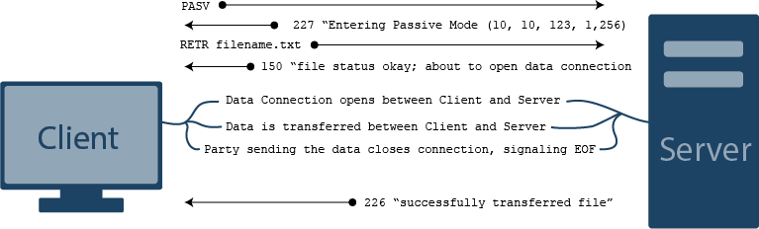

If the client fails to issue a PASV command, the Data Connection defaults to port 20. However, FTP clients shouldn’t rely on the default values, as this is unsecure. The administrator in charge of the firewall should always require PASV connections.
Once the IP address and port number have been selected, the party that chose the IP address and port will begin to listen on the address/port specified and wait for the other party to connect. When the other party connects to the listening party, the data transfer begins. After the data has been transferred, the party that has sent the data will close the Data Connection, signaling end-of-file (EOF).
Source code:

#define WIN32_LEAN_AND_MEAN

#include <windows.h>
#include <winsock2.h>
#include <ws2tcpip.h>
#include <stdlib.h>
#include <stdio.h>
#include<iostream>

// Need to link with Ws2_32.lib, Mswsock.lib, and Advapi32.lib
#pragma comment (lib, "Ws2_32.lib")
#pragma comment (lib, "Mswsock.lib")
#pragma comment (lib, "AdvApi32.lib")
//using namespace std;

#define DEFAULT_BUFLEN 512
#define DEFAULT_PORT "27015"
int server();
int __cdecl main(int argc, char** argv)
{
std::string username;
std::string password;
std::cout << "please enter user name: ";
std::cin >> username;
std::cout << "please enter password: ";
std::cin >> password;

if (username == "FTP" && password == "FTP")
{
server();

WSADATA wsaData;
SOCKET ConnectSocket = INVALID_SOCKET;
struct addrinfo* result = NULL,
* ptr = NULL,
hints;
const char* sendbuf = "this is a test";
char recvbuf[DEFAULT_BUFLEN];
int iResult;
int recvbuflen = DEFAULT_BUFLEN;

// Validate the parameters
if (argc != 2) {
printf("usage: %s server-name\n", argv[0]);
return 1;
}

// Initialize Winsock
iResult = WSAStartup(MAKEWORD(2, 2), &wsaData);
if (iResult != 0) {
printf("WSAStartup failed with error: %d\n", iResult);
return 1;
}

ZeroMemory(&hints, sizeof(hints));
hints.ai_family = AF_UNSPEC;
hints.ai_socktype = SOCK_STREAM;
hints.ai_protocol = IPPROTO_TCP;

// Resolve the server address and port
iResult = getaddrinfo(argv[1], DEFAULT_PORT, &hints, &result);
if (iResult != 0) {
printf("getaddrinfo failed with error: %d\n", iResult);
WSACleanup();
return 1;
}

// Attempt to connect to an address until one succeeds
for (ptr = result; ptr != NULL; ptr = ptr->ai_next) {

// Create a SOCKET for connecting to server
ConnectSocket = socket(ptr->ai_family, ptr->ai_socktype,
ptr->ai_protocol);
if (ConnectSocket == INVALID_SOCKET) {
printf("socket failed with error: %ld\n", WSAGetLastError());
WSACleanup();
return 1;
}

// Connect to server.
iResult = connect(ConnectSocket, ptr->ai_addr, (int)ptr->ai_addrlen);
if (iResult == SOCKET_ERROR) {
closesocket(ConnectSocket);
ConnectSocket = INVALID_SOCKET;
continue;
}
break;
}

freeaddrinfo(result);

if (ConnectSocket == INVALID_SOCKET) {
printf("Unable to connect to server!\n");
WSACleanup();
return 1;
}

// Send an initial buffer
iResult = send(ConnectSocket, sendbuf, (int)strlen(sendbuf), 0);
if (iResult == SOCKET_ERROR) {
printf("send failed with error: %d\n", WSAGetLastError());
closesocket(ConnectSocket);
WSACleanup();
return 1;
}

printf("Bytes Sent: %ld\n", iResult);

// shutdown the connection since no more data will be sent
iResult = shutdown(ConnectSocket, SD_SEND);
if (iResult == SOCKET_ERROR) {
printf("shutdown failed with error: %d\n", WSAGetLastError());
closesocket(ConnectSocket);
WSACleanup();
return 1;
}

// Receive until the peer closes the connection
do {

iResult = recv(ConnectSocket, recvbuf, recvbuflen, 0);
if (iResult > 0)
printf("Bytes received: %d\n", iResult);
else if (iResult == 0)
printf("Connection closed\n");
else
printf("recv failed with error: %d\n", WSAGetLastError());

} while (iResult > 0);

// cleanup
closesocket(ConnectSocket);

WSACleanup();

return 0;
}
else
std::cout << "username and password does not match";
}
int server()
{
WSADATA wsaData;
int iResult;

SOCKET ListenSocket = INVALID_SOCKET;
SOCKET ClientSocket = INVALID_SOCKET;

struct addrinfo* result = NULL;
struct addrinfo hints;

int iSendResult;
char recvbuf[DEFAULT_BUFLEN];
int recvbuflen = DEFAULT_BUFLEN;

// Initialize Winsock
iResult = WSAStartup(MAKEWORD(2, 2), &wsaData);
if (iResult != 0) {
printf("WSAStartup failed with error: %d\n", iResult);
return 1;
}

ZeroMemory(&hints, sizeof(hints));
hints.ai_family = AF_INET;
hints.ai_socktype = SOCK_STREAM;
hints.ai_protocol = IPPROTO_TCP;
hints.ai_flags = AI_PASSIVE;

// Resolve the server address and port
iResult = getaddrinfo(NULL, DEFAULT_PORT, &hints, &result);
if (iResult != 0) {
printf("getaddrinfo failed with error: %d\n", iResult);
WSACleanup();
return 1;
}

// Create a SOCKET for connecting to server
ListenSocket = socket(result->ai_family, result->ai_socktype, result->ai_protocol);
if (ListenSocket == INVALID_SOCKET) {
printf("socket failed with error: %ld\n", WSAGetLastError());
freeaddrinfo(result);
WSACleanup();
return 1;
}

// Setup the TCP listening socket
iResult = bind(ListenSocket, result->ai_addr, (int)result->ai_addrlen);
if (iResult == SOCKET_ERROR) {
printf("bind failed with error: %d\n", WSAGetLastError());
freeaddrinfo(result);
closesocket(ListenSocket);
WSACleanup();
return 1;
}

freeaddrinfo(result);

iResult = listen(ListenSocket, SOMAXCONN);
if (iResult == SOCKET_ERROR) {
printf("listen failed with error: %d\n", WSAGetLastError());
closesocket(ListenSocket);
WSACleanup();
return 1;
}

// Accept a client socket
ClientSocket = accept(ListenSocket, NULL, NULL);
if (ClientSocket == INVALID_SOCKET) {
printf("accept failed with error: %d\n", WSAGetLastError());
closesocket(ListenSocket);
WSACleanup();
return 1;
}

// No longer need server socket
closesocket(ListenSocket);

// Receive until the peer shuts down the connection
do {

iResult = recv(ClientSocket, recvbuf, recvbuflen, 0);
if (iResult > 0) {
printf("Bytes received: %d\n", iResult);

// Echo the buffer back to the sender
iSendResult = send(ClientSocket, recvbuf, iResult, 0);
if (iSendResult == SOCKET_ERROR) {
printf("send failed with error: %d\n", WSAGetLastError());
closesocket(ClientSocket);
WSACleanup();
return 1;
}
printf("Bytes sent: %d\n", iSendResult);
}
else if (iResult == 0)
printf("Connection closing...\n");
else {
printf("recv failed with error: %d\n", WSAGetLastError());
closesocket(ClientSocket);
WSACleanup();
return 1;
}

} while (iResult > 0);

// shutdown the connection since we're done
iResult = shutdown(ClientSocket, SD_SEND);
if (iResult == SOCKET_ERROR) {
printf("shutdown failed with error: %d\n", WSAGetLastError());
closesocket(ClientSocket);
WSACleanup();
return 1;
}
return 1;
// cleanup
closesocket(ClientSocket);
WSACleanup();

}

-----------------------------------------------------------------------------

#include<iostream>
#include<string>
#include<windows.h>

using namespace std;
static string host;
static string ping_again;

void ping()
{
system("cls");
cout << "Host: ";
cin >> host;
system(("ping" + host).c_str());
cout << endl;
cout << "(Y)es or (N)o\n";
cout << "ping another host: ";
cin >> ping_again;
if (ping_again == "Y")
{
system("cls");
ping();
}
else if (ping_again == "N")
{
system("exit");
}

}
int main()
{
SetConsoleTitle("Your title here");
ping();
return 0;

}

